**COMSATS University Islamabad, Abbottabad Campus**

**Department of Computer Science**

**Project Proposal**

**E-Voting System**

**CSC392 Object Oriented Software Engineering**

**Group Members:**

Abid (SP21-BSE-085) **(Leader)**

Abdul Basit Yousufzai (SP21-BSE-092)

Ali Sina (SP21-BSE-089)

Abdul Basit (SP21-BSE-087)

Hayatullah (SP21-BSE-080)

Faisal Hassanzada (SP21-BSE-28)

Ahmad Ikhlas Safi (SP21-BSE-088)

Muhammad Bilal (FA20-BSE-071)

Ashiqullah (SP21-BSE-084)

Table of Contents

CHAPTER 1 PROJECT PROPOSAL 3

Introduction 3

Vision and Business Case 3

Use-Case Model 3

Supplementary Specification 3

Glossary 3

Risk List & Risk Management Plan 3

CHAPTER 2 USE CASES 4

Use Case Diagram 4

Brief Level Use Cases 4

Student Name 1 (Registration Number 1) 4

Student Name 1 (Registration Number 1) 5

# CHAPTER 1 PROJECT PROPOSAL

## Introduction

This is Desktop based Application there is a need to update voting technologies to improve trust, reliability, and convenience. We introduce an E-voting system for electronic voting based on advanced technology. This system ensures that encrypted votes on the reliably counted, while ensuring voter privacy. The primary way voters cast their ballots is by using electronic voting stations, which will send the encrypted ballots to appropriate voters.

We designed the system with the following criteria in mind, based on previous literature.

* Privacy - Keeping an individual’s vote secret
* Eligibility - Allowing only registered voters to vote, with each such voter voting only once
* Hiding interim results - Partial results should not be released during the voting period
* Verifiability - The ability to trust the vote tallying process
* Receipt-Freeness - Voters should be unable to prove to a third party that they voted in a particular way. This is required to prevent coercion
* Convenience - Voters must be able to vote easily, and everyone who is eligible must be able to vote.

## Vision and Business Case

We present a new electronic voting system that employs block chain technologies along with cryptographic techniques to obtain verifiable results while still retaining voter privacy. At a high-level, a vote is encrypted and a proof of the vote is sent to a public block chain from an electronic polling station. A centralized authority then decrypts all the votes and posts the tally along with a proof that the reported results are correct and the voter can check that their vote was cast.

## Use-Case Model

Following is the functional requirement of our system.

1. **Register**

The System should register the Voter and IEC (Independent Election Commission) after verifying it from the MPR (Ministry of population and Registration)

1. **Login**

The System should allow those users who are registered in the system and verified users can be login to the system through their valid ID.

1. **View Dashboard**

The Dashboard will view the details of the voter and IEC (Independent Election Commission) member.

1. **Add Election**

The IEC will be able to add election to the system and also its type of it whether it is presidential and parliamentary.

1. **View Election**

The IEC and Voter will be to see the election and also its type.

1. **Remove Election**

The IEC will be able to remove election after expiring time of the election.

1. **Add candidate**

The IEC will be able to Add candidate to the system after fulfilling the requirements of IEC.

1. **View candidate**

The Voter and IEC will be able to view candidate of his/her area.

1. **Remove candidate**

The IEC will be able to remove candidate if he/she doesn’t fulfill the requirement.

1. **Conduct Election**

The IEC will be able to conduct election after arranging an election type.

1. **Set voting area**

Areas will be set for voting so that the voters can easily be able to vote their candidate from their specific polling station.

1. **Set Polling station**

Stations will be set in specific areas where possible for population of that area to vote their candidate.

1. **Add Polling station**

The poling stations will be added according to needs and necessity of it which main reason can be population.

1. **Remove Polling station**

There may be condition that there will be more stations than population so the IEC will remove the extra stations.

1. **Search Polling station**

The IEC will be able to search the station if it had any problem and by fixing it online.

1. **Display Candidate**

The candidate will be displayed to voters and IEC so that both can see the candidates.

1. **Caste vote**

The voter will be able to select and vote to their favorite voter

1. **Generate Result**

The votes will be gathered and counted by IEC and will be announced.

1. **Logout**

The IEC will be logged out of the system after the result announced and election done.

## Supplementary Specification

These are some Non Functional Requirements as we together in this inception phase. Security requirements are important factors in this system as classified data will be stored in the database. User validation will be done during login to insure that the user is valid and that the user only has access to his or her permission data. General users will only have access through the user interface. The system will have consistent interface formats and button sets for all forms in the application, will have a form based interface for all data entry and viewing formats. The system will be easily maintained by authorized trained person and it shall respond as fast as possible in generating vote counting and producing the result for each polling station.

## Glossary

* **IEC: Independent Election commission**
* **MPR: Ministry of Population Registration**

## Risk List & Risk Management Plan

A critical aspect of project management is developing a risk assessment tool that realistically identifies possible sources of risk, considers any mitigating factors and provides appropriate responses. This will involve a full assessment of potential security risks, as these are among the most critical for an electronic voting and counting system and should be carefully considered; but other types of risk related to logistical or even legal issues should be considered as well.

Although each project will have its own risks, a risk plan should address:

* Unauthorized intervention of third parties in the voting process (hacking attacks)
* Risk of (large-scale) manipulation by (small group of) insiders
* More difficult to detect and identify the source of errors and technical malfunctions than with conventional procedures (lack of transparency and lack of understanding of the system by non-experts)
* Possibility that fully digitized system would fail to produce results and lack physical back-up records, making a public recount difficult or impossible
* Requirement of system certification. However, no widely agreed (international) standards for certification available
* Reduced level of control by EMBs; high dependence on vendors and technical expertise
* Need for additional voter education campaigns
* Risk of (loosing) public trust in the election/referendum process
* Increased costs (purchasing and maintaining of e-voting system)

A risk management plan should be developed early in the project and should be made publicly available so as to increase public confidence in the election authorities’ ability to face the challenges of implementing electronic voting or counting.

Election observers should review the project management documents on an ongoing basis and highlight any gaps that they identify in a timely manner so that recommendations can be made to improve the project. Using the project documents, observers can also provide oversight to ensure that deadlines are being met and the project remains on track in terms of its timeline. Observers should also review the risk management plan to determine whether risks have been realistically anticipated and countermeasures devised. Observers are in a key position to provide this assessment of project progress to citizens on an ongoing basis through periodic statements. Such reporting can enhance public confidence in the election administration and also highlight any areas of concern in a timely manner so that action can be taken.

# CHAPTER 2 USE CASES

## Use Case Diagram

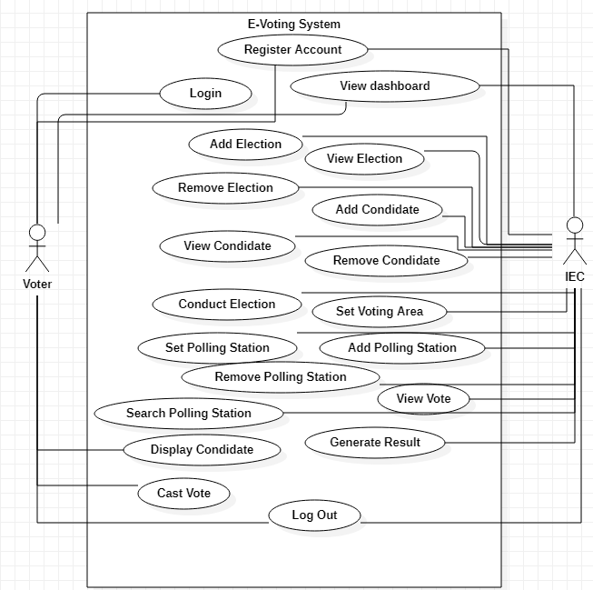

## Brief level use case:

### Muhammad Bilal (FA20-BSE-071)

#### Use Case UC1: Add Election:

IEC open the EVM desktop application. IEC press the button Add Election on the home screen of the EVM.IEC will redirect to the Add Election page then he enter the required credential’s like select province , Election type, Polling station , Election Officer , Election date , Start time and End time. Then he press add election button on add election page to create Election.

#### Use Case UC2: Remove Election:

IEC open the EVM desktop application. IEC press the button remove Election on the home screen of the EVM.IEC will redirect to the remove Election page then he enter the required credential’s like select province , Election type, Polling station , Election Officer , Election date . Then he press remove election button on remove election page to remove Election.

## Fully dressed use case:

### Muhammad Bilal (FA20-BSE-071)

#### Use Case UC1: Add Election:

|  |  |
| --- | --- |
| Use Case | Add Election |
| Scope | Information for election has been entered into the system |
| Level | **IEC**(Independent Election Commission) |
| Primary Actor | IEC(Independent Election Commission) |
| Stack Holders and interests | **Government:** Government who wants secure and fair election without any kind of corruption or Re polling of voting.  **IEC**: IEC has the control to remove those candidates who are not eligible for elections.  **Voters:** Voters who wants to Pol their votes to their favorite candidate can easily pol vote to them from home or anywhere else. |
| pre-Condition | * The IEC must have a stable internet connection in order to add election. * IEC is authenticated to enter details |
| Post Condition | * The election should be successfully add to the E-Voting system and announced on time. * Elections are created |
| Main Success scenario | * IEC choose a date,duration for election and fills all revelent information of the election. * IEC conform the election. * System Create new election. |
| Special Requirements | **•** Touch screen User interface on a large flat panel monitor. Text screen should be visible from 1 meter.  • Response of selection of area should be done within 30 seconds.  • The 2 languages of the country Pashto, Dari should be displayed on the screen. |
| Technology and data variation list | * IEC can override the operation by clicking on the back button. * By putting the thumb of the candidate on the fingerprint sensor the details will be displayed on the screen. * We can remove the candidate by touching on the screen and also with the help of mouse. |
| Frequency of occurrence | This can occur when IEC look after all the details of the Individual candidate. |
| miscellaneous | Which candidate is being removed?  Why the candidate is being removed? |
|  | |

#### Use Case UC2: Remove Election:

|  |  |
| --- | --- |
| Use Case | Remove Election |
| Scope | Information for election has been entered into the system |
| Level | **IEC**(Independent Election Commission) |
| Primary Actor | IEC(Independent Election Commission) |
| Stack Holders and interests | **Government:** Government who wants secure and fair election without any kind of corruption or Re polling of voting.  **IEC**: IEC has the control to remove those candidates who are not eligible for elections.  **Voters:** Voters who wants to Pol their votes to their favorite candidate can easily pol vote to them from home or any where else. |
| pre-Condition | * The IEC must have a stable internet connection in order to add election. * IEC is authenticated to enter details |
| Post Condition | * The election should be successfully remove from E-Voting system on time. * Elections are removed or canceled. |
| Main Success scenario | * IEC choose a date,duration for election and fills all revelent information of the election. * IEC conform the election. * System remove election. |
| Special Requirements | **•** Touch screen User interface on a large flat panel monitor. Text screen should be visible from 1 meter.  • Response of selection of area should be done within 30 seconds.  • The 2 languages of the country Pashto, Dari should be displayed on the screen. |
| Technology and data variation list | * IEC can override the operation by clicking on the back button. * By putting the thumb of the candidate on the fingerprint sensor the details will be displayed on the screen. * We can remove the candidate by touching on the screen and also with the help of mouse. |
| Frequency of occurrence | This can occur when IEC look after all the details of the Individual candidate. |
|  | |

# CHAPTER 3 SSD

### Muhammad Bilal (FA20-BSE-071)

#### Use Case UC1: Add Election:

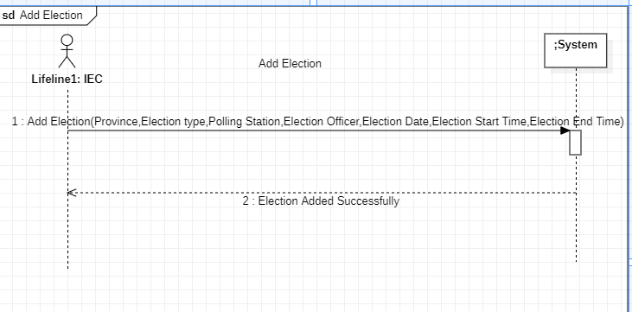

#### Use Case UC2: Remove Election:

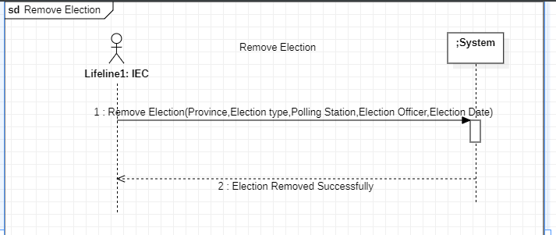

# CHAPTER 4 Operation Contracts – Sections

### Muhammad Bilal (FA20-BSE-071)

#### Use Case UC1: Add Election:

|  |  |
| --- | --- |
| Operation | Add Election(Province,Election type,Polling Station,Election Officer,Election Date,Election Start Time,Election End Time) |
| Cross reference | Use case: Add Election |
| Pre-condition | * The system running correctly * IEC add election successfully |
| Post-condition | * Election added successfully |

#### Use Case UC2: Remove Election:

|  |  |
| --- | --- |
| Operation | Remove Election(Province,Election type,Polling Station,Election Officer,Election Date) |
| Cross reference | Use case: Remove Election |
| Pre-condition | * The system is working respectively * IEC remove election |
| Post-condition | Remove election successfully |

# CHAPTER 7 Domain Model

### Muhammad Bilal (FA20-BSE-071)

#### Use Case UC1: Add Election:

#### Use Case UC2: Remove Election:

## 

# CHAPTER 8 package diagram:

## Muhammad Bilal Fa20-BSe-071

